INTRODUCING

The Micro-Production Unit

MPU

a versatile, economic system
for the production of
high-quality legume Inoculants

A PLANNING GUIDE

;,. .,;
..

NifTAL Center
1000 Holomua Road
Paia, Hawaii 96779 USA

phone 808-579-9568
fax 808-579-8516
Preface

This booklet provides an introduction to the Micro-Production Unit (MPU) for small-scale production of legume inoculants. It is intended to be planning guide, and not an instructional manual.

The MPU system is flexible -- it can be used effectively under a wide range of conditions and with minimal investment. This booklet offers suggestions for facilities design and equipment options for a relatively sophisticated production enterprise. Actual requirements will vary with site, scale of production, and conditions in existing facilities.

Acknowledgements

The MPU is based on research by NifTAL microbiologist Padma Somasegaran (1982 and 1995, reprints attached). This booklet, tables, and graphics were developed by NifTAL inoculant production specialist, Joseph Rourke.

The University of Hawaii NifTAL Center receives core funding from the US Agency for International Development through the Soil Management Collaborative Research Support Program (TropSoils CRSP) to develop and transfer biological nitrogen fixation technologies for sustainable agriculture.

Draft
26 April, 1993
The Micro-Production Unit
(MPU)

The use of inoculants containing rhizobia, a nitrogen-fixing soil bacteria, is a proven biotechnology for enhancing legume production. In many areas, inoculants have substantially increased legume crop yields by maximizing the BNF process. NifTAL's goal is to make effective, low-cost BNF technologies and products available to farmers in developing countries. NifTAL combines applied research, product development, training, technical assistance, and support of commercial enterprises to achieve this goal.

One NifTAL emphasis has been the development and delivery of appropriate technologies for the small-scale production of rhizobial inoculants. The result of this effort is the Micro-Production Unit (MPU). The MPU relies on two key components: the use of a sterile inoculant carrier such as peat, and the dilution of pure broth cultures of rhizobia. By integrating these components, cost-efficient, decentralized, small-scale commercial inoculant production is now possible.

Advantages of the MPU. There are several advantages to producing rhizobial inoculants with the MPU compared to conventional large-scale commercial production methods. These include

* Initial investment costs are reduced. (See Table 1. Comparison of costs and operations time for sterile and non-sterile production modes.)

* The number and size of fermentor vessels for culturing rhizobia are reduced with the dilution technique. (See Table 2. Fermentor capacities and operations time to meet production goals.) Diluting the broth culture increases potential production capability by the amount of the dilution factor.

* High quality inoculants can be produced by diluting broth cultures up to 1000 fold before mixing in sterile peat carrier. See Appendix for articles by Somasegaran for details.

* Production schedules are flexible. Producers can respond to demands for varying inoculant quantities and for a greater variety of specific inoculants.

* The use of a sterile carrier increases the shelf-life of inoculants. Over time (6-9 months), the quality of the sterile peat-based inoculants will be higher than non-sterile inoculants stored under similar conditions.
* Storage of sterile peat-based inoculants require less stringent
conditions. Refrigerated storage is not as critical for maintaining
inoculant quality.
* The MPU can easily be established in rural locations close to legume
production areas, and as a result, distribution costs are reduced.
* Increasing the production capacity of the MPU is easy and
inexpensive. (See Tables 1 and 2. See also Table 3 Potential
production capacities of sterile and non-sterile production modes, and
Table 4. Time requirements for injecting peat bags.) Note : These
worksheets are interactive spreadsheets on computer. See Appendix
for further details.
* Expanding the scale of production is easy and inexpensive.
Fermentors used for small-scale operations will not become obsolete.
Low-volume fermentors may be kept for the production of "custom"
inoculants, late requests, or "starter" cultures for larger fermentors.
Quality control procedures are simpler and more reliable. Because of
the sterile carrier, rapid, direct plating of inoculants will provide
accurate assessments of inoculant quality.

Conditions for Success. There are several conditions for successful inoculant production with the MPU systems.

* The dilution technique requires a reliable source of sterile pre
packaged peat. There are reliable international sources of this peat if
local sources are not available, but potential problems involving
importation, transport, and foreign exchange must be considered.
* Some specialized equipment is needed, such as a sterilizable,
adjustable injection pump system that can deliver set volumes of
diluted cultured broth.
* The system requires a means of sterilizing large quantities of water for
diluting the broth culture.
Sterile peat bags must be injected individually. Mixing large batches
of sterile peat and diluted broth is not economically feasible.
* Aseptic conditions must be maintained during production.
* A trained technical person is needed for certain key operations.

2
i
Guidelines for Setting Up a Micro-Production Unit and
Establishing Inoculant Quality Control

1. Physical Facility

A conceptual plan for a MPU facility addresses the environmental requirements of
specific functions. (See Fig. 1. MPU: Suggested floor plan.) The plan may be i
modified as needed. This layout includes six functional sections:

A) office area,
B) quality control testing area,
C) general area for media prep, glassware washing, etc.,
D) inoculant curing and short-term storage,
E) broth injection area, and
F) clean area for microbiological work.

This plan is based on the assumption that only pre-packaged sterile peat carrier will be used for production. No provisions are made for processing locally-acquired peat.
If indigenous peat will be used, then drying, grinding, weighing, and packaging must I
be done in another area away from the MPU. Dust control is necessary in the peat
processing area.
~i

An isolated area must be designated for the microbiological work. (See Fig. 2. MPU culture and injection area.) Non-essential personnel and materials must be kept out, and traffic should be restricted. Double entrance doors reduce dust. Air supply (air conditioners) to the clean room needs to be effectively filtered to avoid the introduction of contaminants. Maintenance of positive air pressure in the room helps reduce the introduction of unfiltered air from outside. Soil, raw peat, and plant tissue samples must not be brought into this area without special precautions for containment, handling, and disposal.

2. Equipment and Supplies

Table 5 includes general equipment items useful in the production area. Items specific to microbiological activities are listed in Table 6. (Microbiological equipment and supplies checklist.)

3. Strain Transfer, Cell Propagation, and Broth Dilution

A) Preparation of Inoculants

Small-scale inoculant production with the MPU takes advantage of inexpensive
fermentors and simple techniques. (See Fig. 3. MPU production flow.)

3
A starter culture is introduced aseptically to a fermentor such as a modified Erlenmeyer flask. (See Fig. 4. MPU: Steps for inoculation of fermentor.) Rhizobial growth proceeds under standard conditions: 28-30°C for 3-5 days for fast growers and 5-7 days for slow growers. The culture may be aerated by rotating on a orbital shaker or by bubbling air in through a sterile filter.

B) Dilution of Broth and Injection into Carrier

After maturation, the broth is diluted with water or 1 /4 strength Yeast Mannitol Broth (YMB) (See Table 7 for ingredients) at a ratio of 1:100. (See Fig. 5. Dilution and manual injection of broth into sterile peat carrier, and Fig. 6. Selfrefilling syringe for injecting diluted broth into carrier.)

For small-scale production, the use of a manual hand-syringe and separate sterilizable dilution container is recommended. For medium to commercial-scale production, either a peristaltic pump system or the dilution-dispensing pump system are more efficient. (See Fig. 7. Dilution and dispensing of rhizobial broth by pump into peat carrier, and Fig. 8. Diluting and dispensing pump system.) Diluted broth is injected into a sterile, pre-packaged carrier material such as peat. The package is then massaged to mix the diluted broth and carrier, and left for 5-7 days at 28-30°C. (See Table 4. Time required for injecting peat bags.)

4. Rhizobial Strains

Pure cultures of authenticated rhizobia must be obtained from internationally recognized sources and must be specifically recommended for target legumes. Strains must have been tested for purity and effectiveness on their host plants.

Important characteristics of rhizobia include

A) ability to compete with indigenous rhizobia in the soils
B) ability to adapt to the environmental conditions encountered in the soil
C) ability to persist in the soil
D) ability to fix nitrogen effectively with local legume genotypes and
cultivars.

One of the advantages of a small-scale MPU system is that authenticated, selected, and pre-tested rhizobial cultures may be obtained in a preserved form. These cultures can be reconstituted as a liquid culture for direct transfer to a fermentor (see Fig. 4.) Multiple samples of preserved inoculant strains may be obtained and stored for later use. This method reduces the likelihood of contamination, and eliminates the need for maintaining a rhizobial culture collection and authenticating cultures on plants.

4
5. Carrier Material

The following analysis of an Australian sedge peat marketed by Bio-Care Technology, New South Wales can be used as reference when characterizing other potential carrier materials.

The initial pH ranges between 4 and 5, depending on the depth from which it is mined. The pH must be adjusted to 6.5 - 7.2 by adding CaC03 at a rate of approximately 5% (w/w).

The initial moisture content is approximately 15%. Peat sterilized by gamma irradiation, steam sterilization, or dry heat and may vary in moisture content, which affects the amount of diluted broth which can be mixed with the carrier material.

Particle size after grinding varies by batch. More than 90% of the final peat carrier will pass through 325 mesh (50 ,um) screen.

The Bio-Care peat carrier material is sterilized by Cobalt 60 irradiation and has the following characteristics.

Organic matter: 80-85%
Cation exchange capacity : 80 mEq/100 g
Water holding capacity: 200 % (w/v)
Chemical composition:

N % 1.90 - 2.40
P % 0.03
K % 0.06
Mg% 0.57 - 0.64
Ca % 1.10 - 1.60
Na% 0.22
Cl% 0.10 - 0.11
Al % 1.40 - 1.70
Fe % 0.20 - 0.40
Cu 5 - 30 ppm
Zn 15 - 65 ppm
B 4 - 10 ppm
NaCl 0 - 0.15
6. Labels for Rhizobial Inoculants

Requirements for labelling inoculants vary among countries. (See Fig. 9. Sample label for inoculants.) Each packet of inoculant should contain the following information:

A) name, address, phone and FAX numbers of the inoculant production
facility
B) name of legume host
C) expiration date after which the inoculant should not be used
D) batch number
E) precautions
F) instructions for storage
G) directions for use
H) net weight of unit size produced
I) quantity of seed to be inoculated

7. Quality Control

A) Industry Standards

Inoculant quality is ultimately judged by the farmer in the field. Once produced, the inoculant is subject to a long chain of "unknown factors" that may affect its quality. Temperature, desiccation, poor aeration, pH drift, contamination, and toxicity from the carrier material may all cause deterioration of the product. One of the advantages of MPU-produced inoculants is that they retain their quality and shelf-life longer than inoculants produced in non-sterile carriers.

Minimum standards of acceptability are based on the number of viable rhizobia per gram of inoculant. These standards vary between countries. For example:

5-10 x 10⁷ viable cells/gram - USSR
4-25 x 10⁹ cells/gram - The Netherlands
1 x 10⁸ cells/gram - Australia, New Zealand, India, and
Czechoslovakia

B) Plant Growth Area for Testing Inoculants

The primary advantage in quality control procedures when using a sterile carrier is that the rhizobia in the inoculant can be enumerated directly by plating methods. When these direct plating methods are combined with other presumptive tests for rhizobia, indirect enumeration of rhizobia by MostProbable-Number (MPN) plant infection methods are not required.

6
Depending on the situation, environmentally-controlled areas for plant growth can be used to:

1) authenticate cultures received from germplasm depositories,
2) estimate the numbers of infective rhizobia in soils or non-sterile
inoculant carriers using Most Probable Number (MPN) plant
infection tests, and
3) measure the effectiveness of strains on the plant.

Primary considerations for the physical design of the plant growth room are:

1) protection from outside contamination by other rhizobia and
microorganisms,
2) adequate lighting (approximately 16,000 lux),
3) adequate relative humidity (65 - 70%),
4) air circulation, and
5) ventilation of excess heat to maintain a temperature of
approximately 20°C during light period and 15°C for dark period.

(See Fig. 1. MPU: Suggested floor plan, and Fig. 10. Plant growth area.)

If the area is exposed to adequate sunlight, greenhouse-type construction should be considered. Temperature and humidity must be regulated to support plant growth.

If the area is not exposed to sufficient natural light, an enclosed growth-room with artificial sources of illumination should be considered. Warm-white or cook white fluorescent lighting mounted to the wall or suspended over-head are often used. Wall-mounted lighting does not encourage excessive vertical growth in plants, and is often preferred. The ballasts for fluorescent lights creates heat and should be located outside the growth area. An alternate lighting system is a high-intensity discharge sodium lamp, but this system generates high temperatures and is costly. Day-length with the artificial lights must be regulated by timers. Depending on the legume species, lighting periods are generally 12 to 16 hours.

C) Quality Control Measures

Broth cultures should be tested by presumptive tests such as gram stains, direct microscopy, plating on indicator media, measuring pH, etc. Rhizobia in inoculants can be enumerated by direct-plating techniques when inoculants are produced with sterile carriers. This direct plate count will also reveal the presence of any contaminating organisms.

7
It must be emphasized that the direct-plating method is only applicable to inoculants produced by sterile technique. Most contaminating organisms grow faster than rhizobia and will interfere with the direct-plate count. Any contamination indicates the need to further test the inoculant batch.

The plant infection technique provides indirect estimates of rhizobial populations based on Most-Probable-Number (MPN) tables or the MPNES computer-assisted program. MPN assumes that nodulation will occur if a single viable and infective rhizobia is present, and that the lack of nodules indicates the absence of compatible, viable rhizobia.

The only way to ensure that the symbiotically correct rhizobial strain for a specific legume host is in the inoculant is to test the inoculant on the host. It is conceivable that inoculants may have adequate populations of rhizobia, but through some error, these rhizobia may not be the correct strain for the intended host.

D) Testing Inoculants by Batch Lot Numbers

The Australian Inoculants Research and Control Service (AIRCS) test commercially-prepared inoculants by the direct plate counting technique. AIRCS recommends random selection of seven units from a batch.
--- five of these units are tested initially
--- if one unit fails on initial testing, it is re-tested
--- if, on the second trial it meets all criteria, the entire batch
lot is passed
--- if, on the second trial it fails,
--- the additional two units are tested
--- if either of these units fails, the entire batch lot fails

Inoculant samples selected at random for testing should be kept at 2-10°C.

The sampled units should be selected on a Batch Lot Number basis. If a problem is detected in samples selected from a specific batch lot number, units of that specific batch could be further tested to determine if the problem was isolated to that batch or continued throughout production. Other batches that pass the quality control tests can be released for sales.

Producers should test inoculants from retail outlets to ensure that conditions associated with transportation and storage have not altered the quality of the inoculant. Samples from retail outlets should be stored in the refrigerator until they are tested.

8
8. Heating Requirements for Various Fermentor Volumes

NifTAL is testing the substitution of electric immersion heater probes for LPG (Liquid Propane Gas) burners for sterilizing fermentors. Some disadvantages of LPG burners include

A) use of an open flame,
B) excess heat,
C1 carbon and soot deposits,
D) location of the fermentor outside the laboratory away from heat, and
E) the need to move a full sterile fermentor back into a "clean" area for
inoculation and fermentation.

Electric immersion heaters address each of the disadvantages and offer a superior alternative compared to LPG burner use. The greatest advantage of electric heating is the convenience of sterilizing the fermentor in the same area where inoculation and rhizobial production will take place, usually a clean laboratory. In contrast, the use of LPG generates too much heat for this situation. However, LPG use may be advantageous for other reasons in some situations.

By using an LPG gas burner rated at 90,000 BTU capacity, 100 litres of non-sterile broth in a stainless steel 141 litre NifTAL-developed fermentor can be sterilized in approximately 90 minutes. The broth is heated from (70°C) to (251 °C), held at 251 °C for 30-45 minutes, then cooled by internal coils circulating cold water. (See Table 8. Kilowatt hours required to heat water for different volumes and time, and Fig. 12 Kilowatt hours required to heat water.)

9
Tables and Figures

10
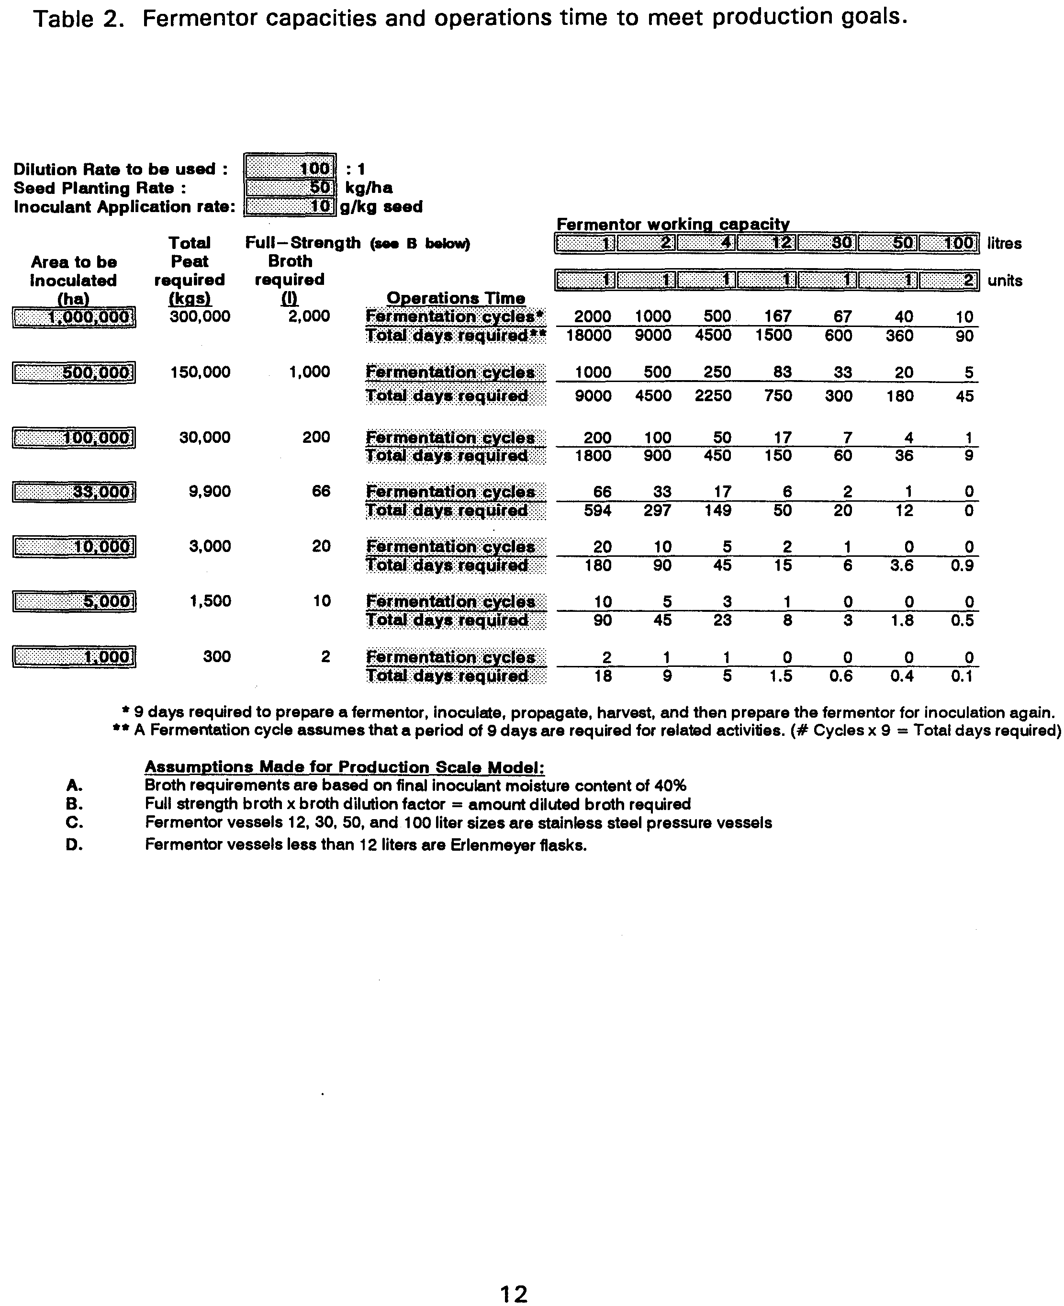
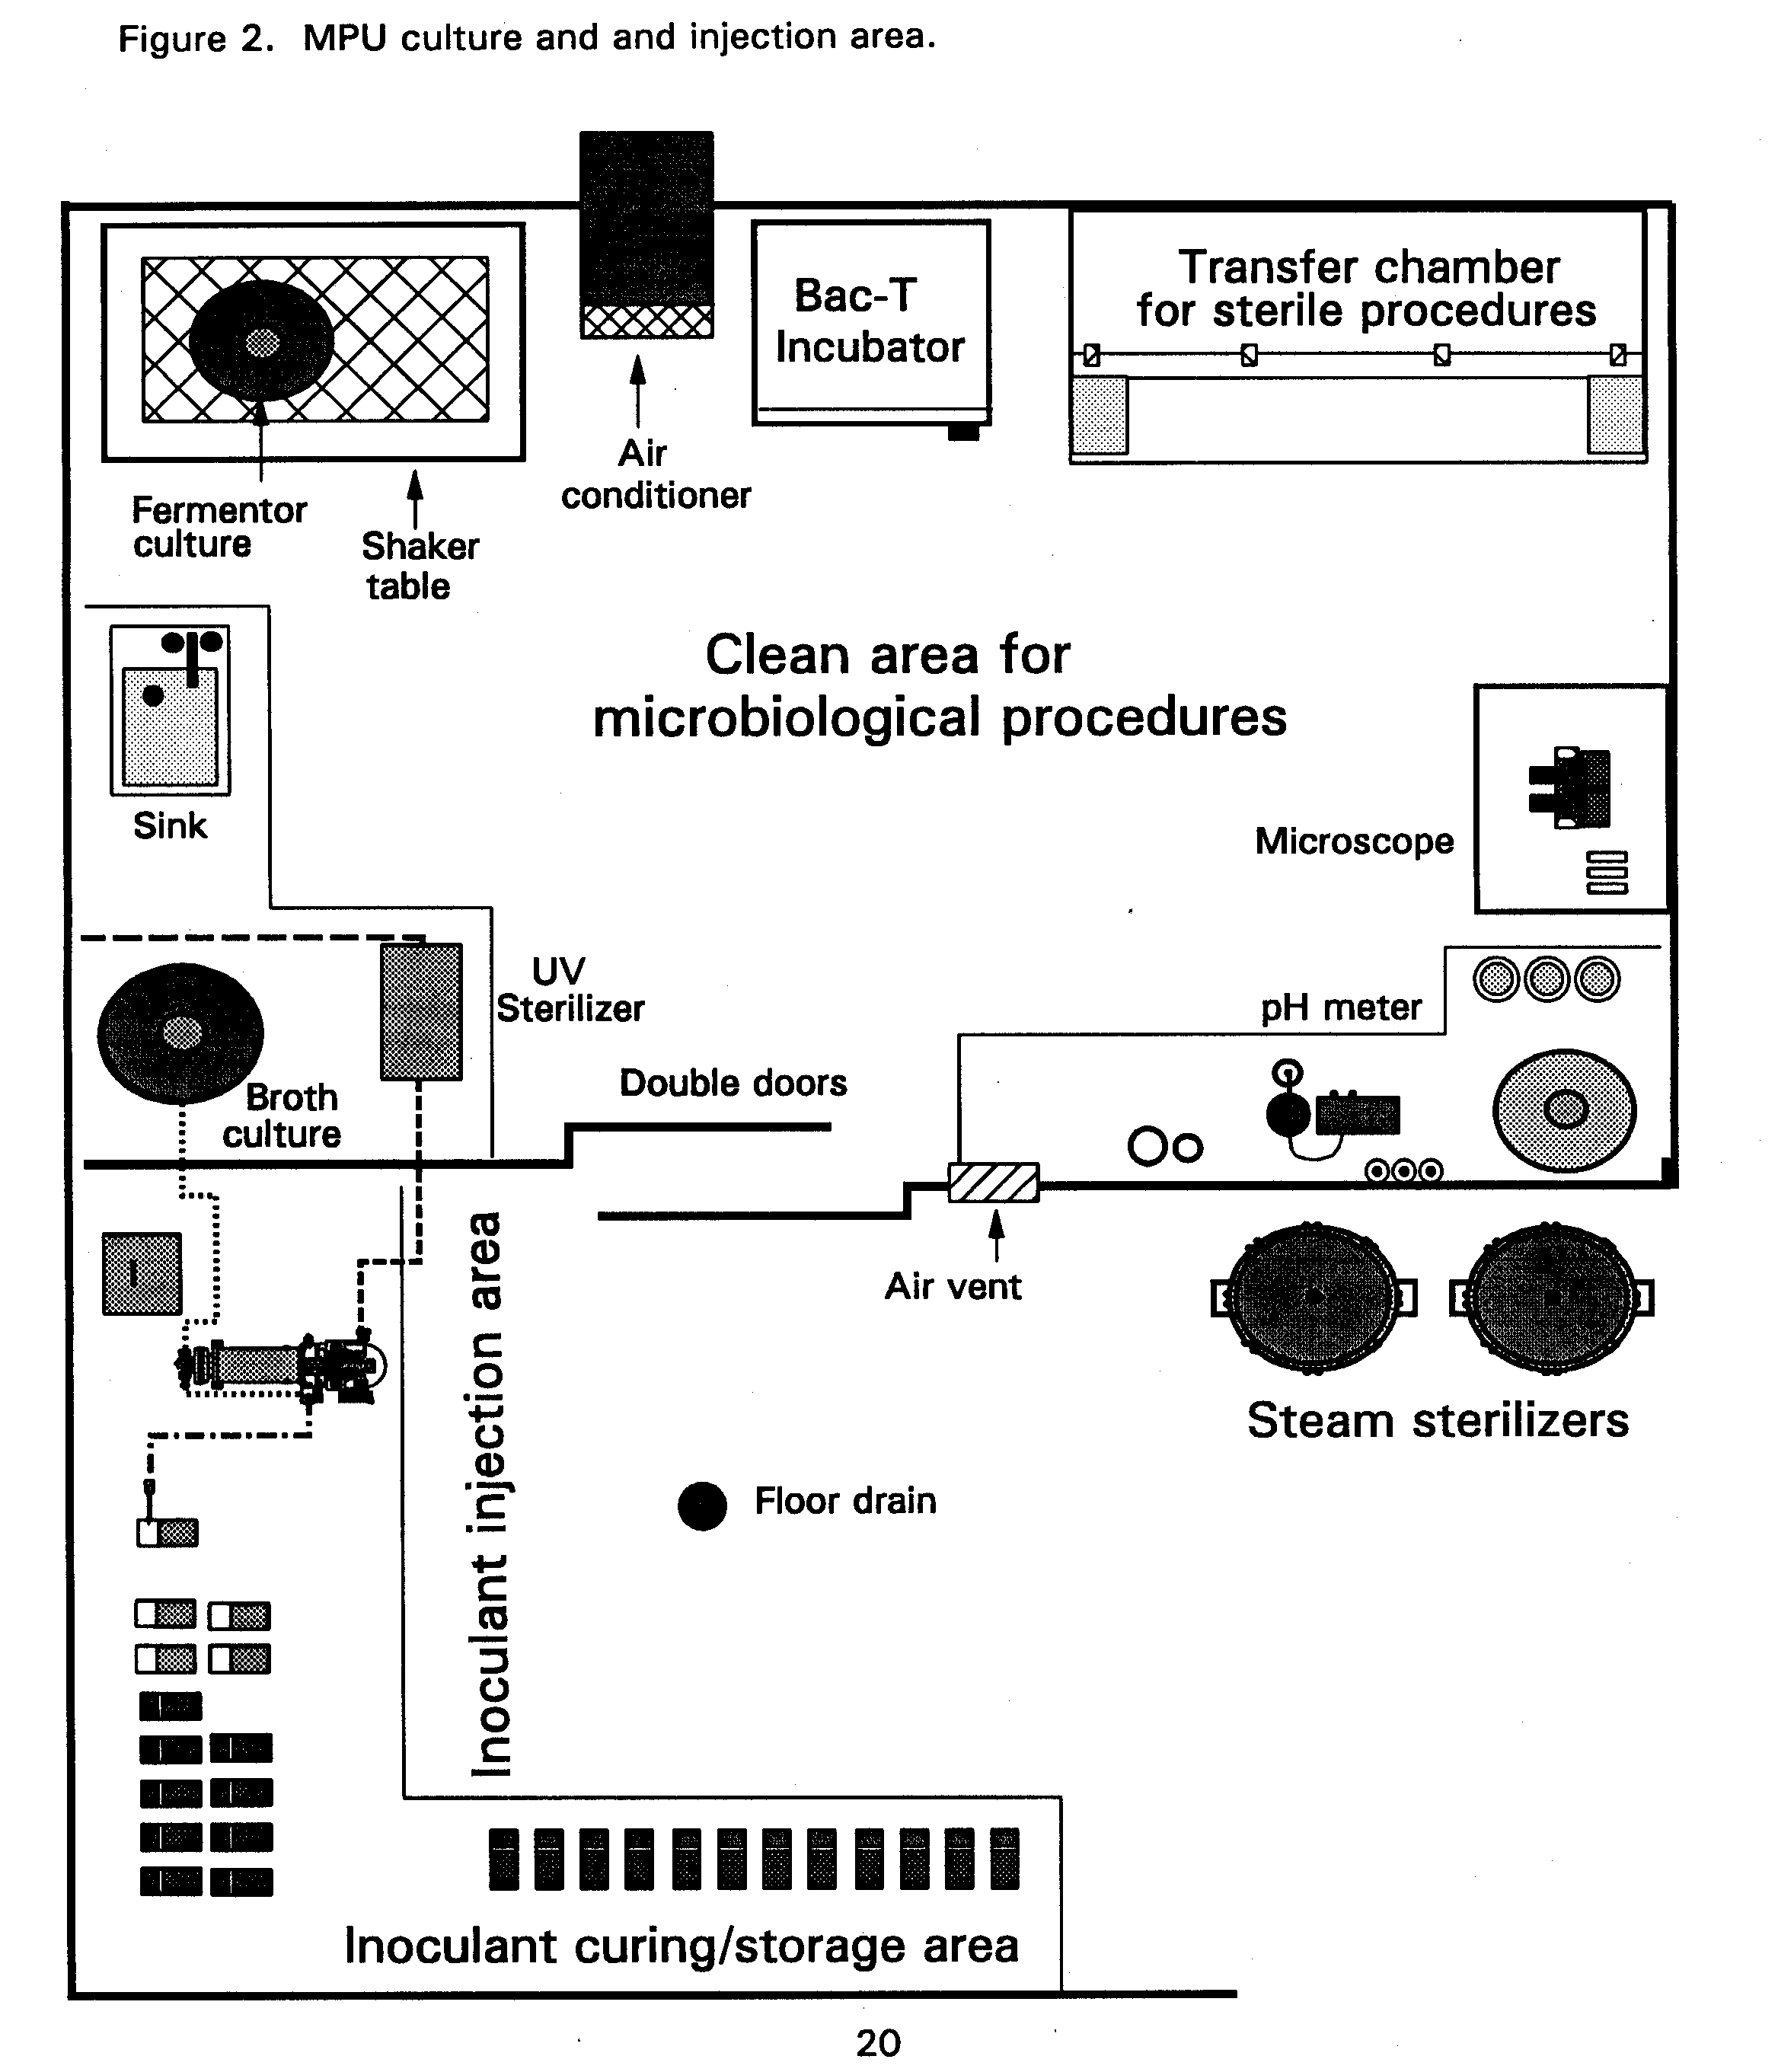
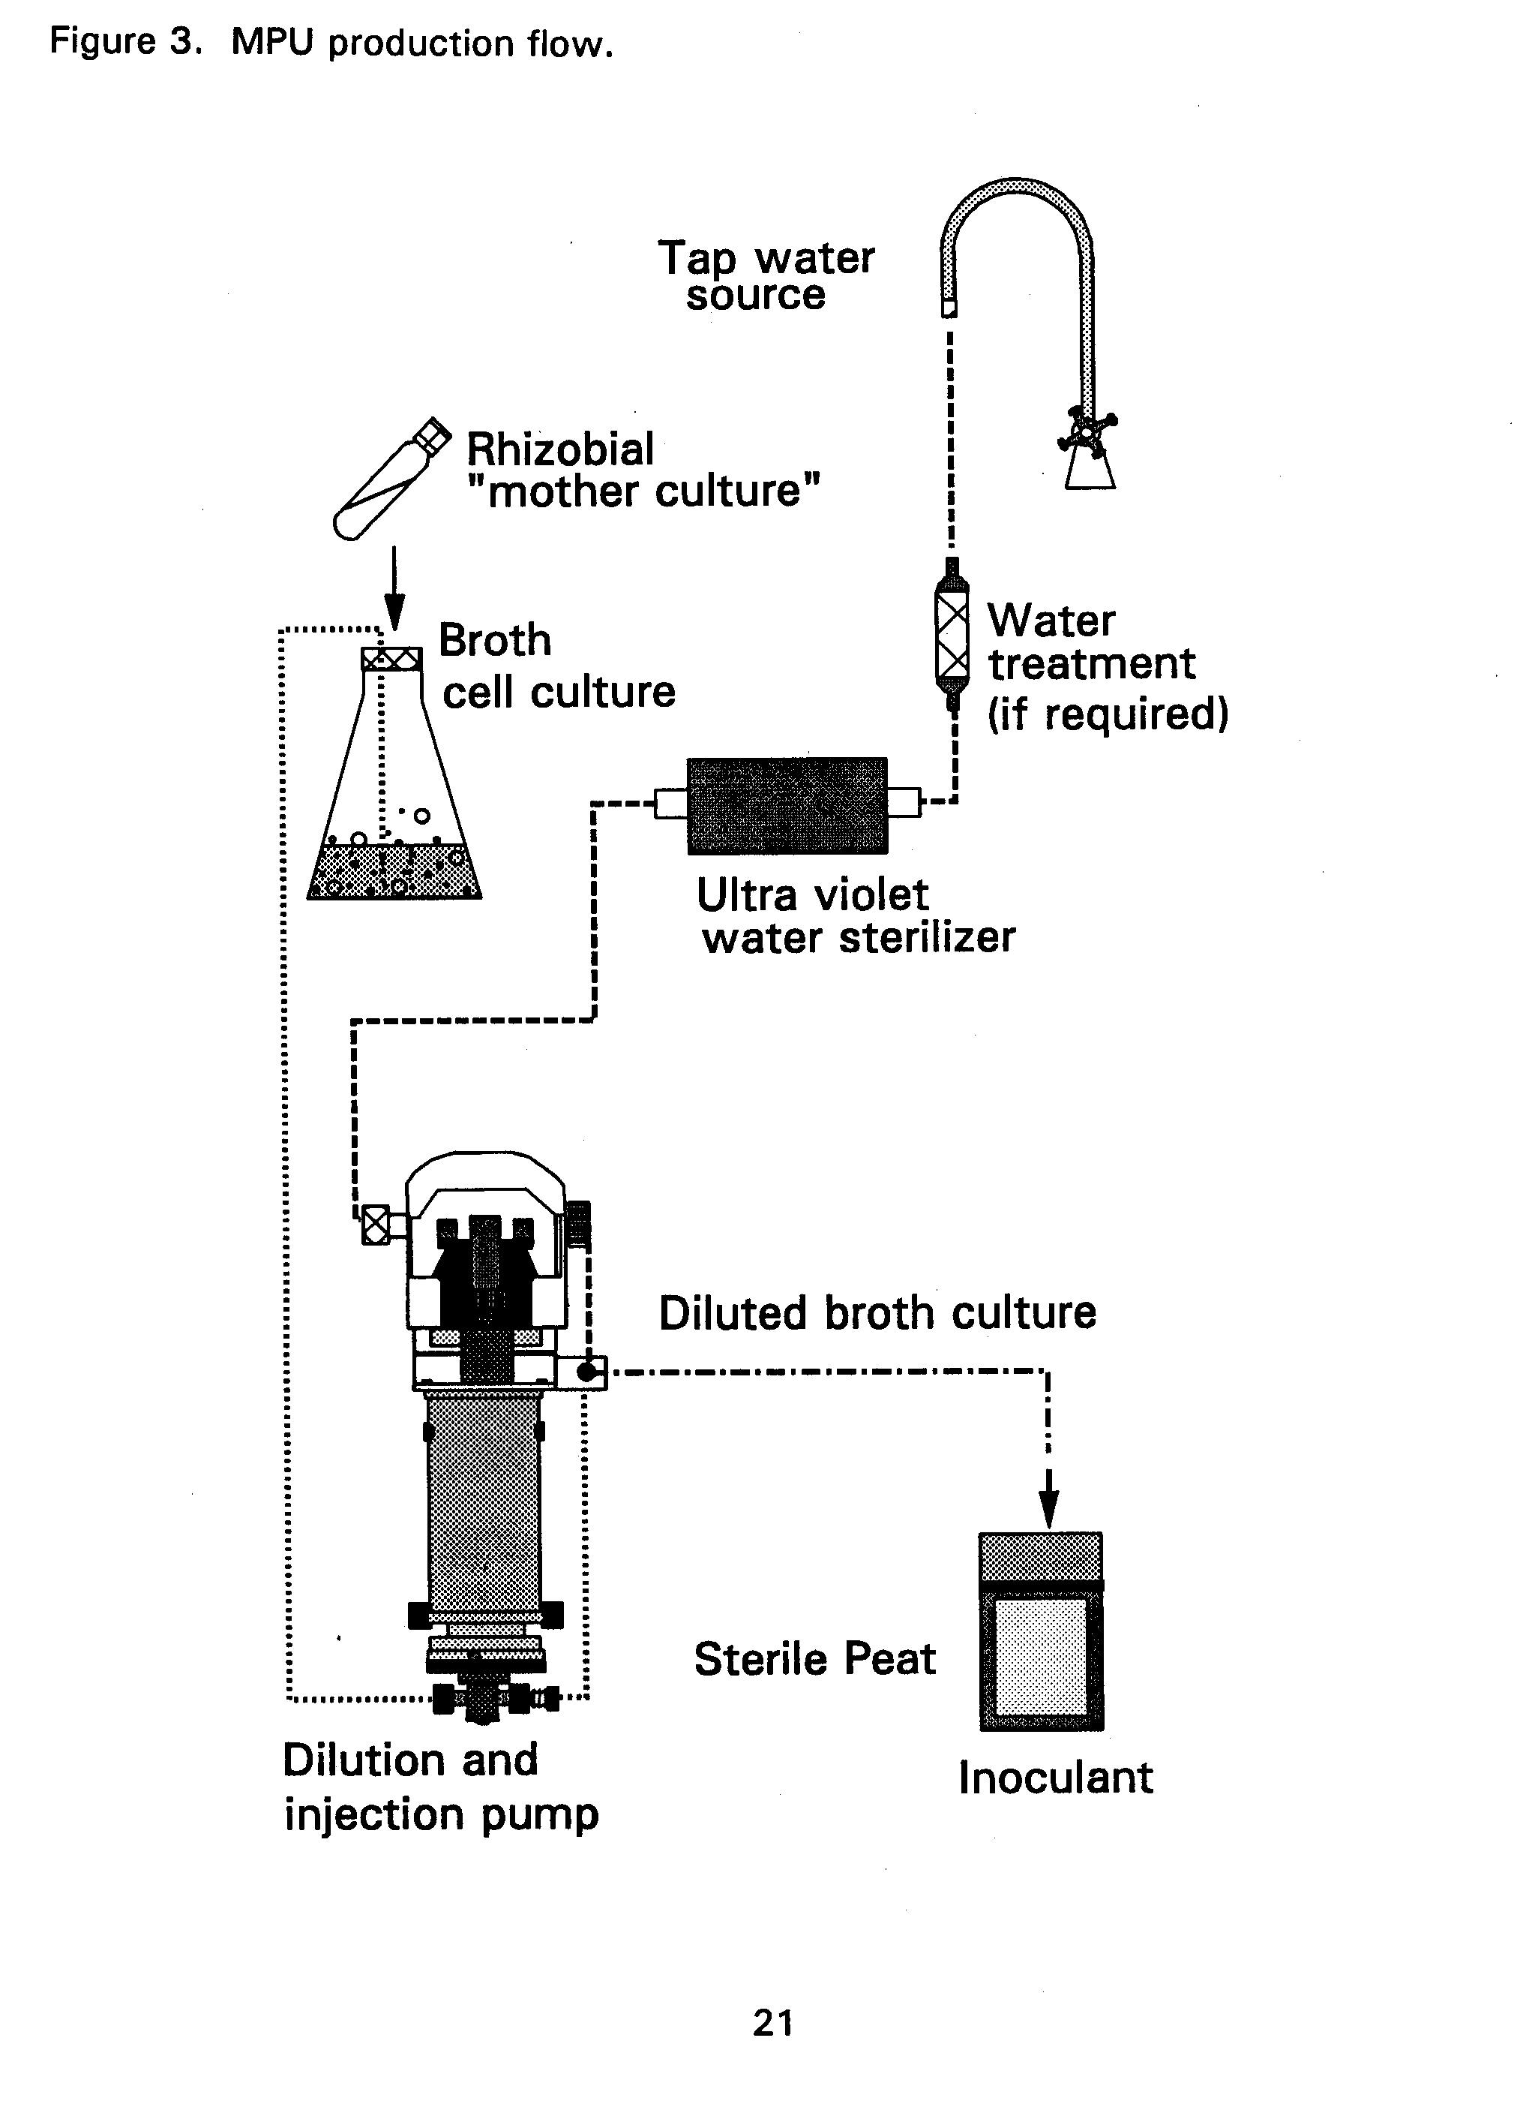
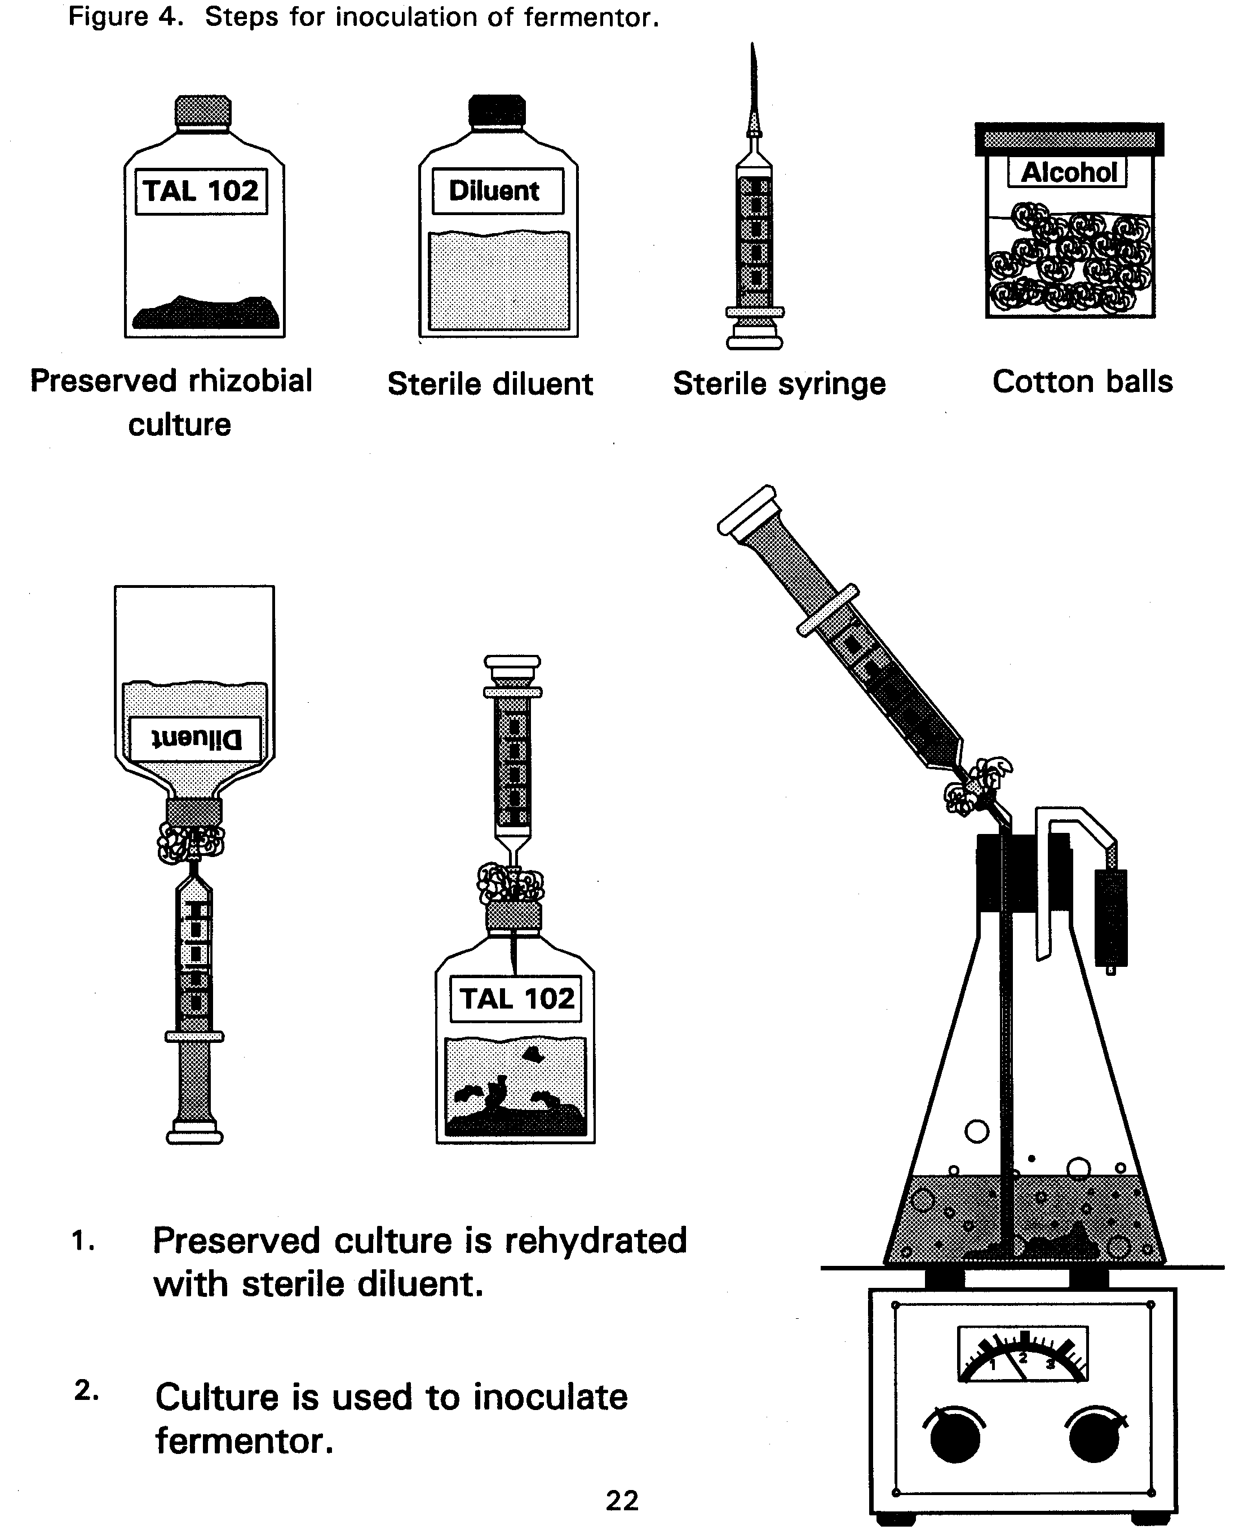
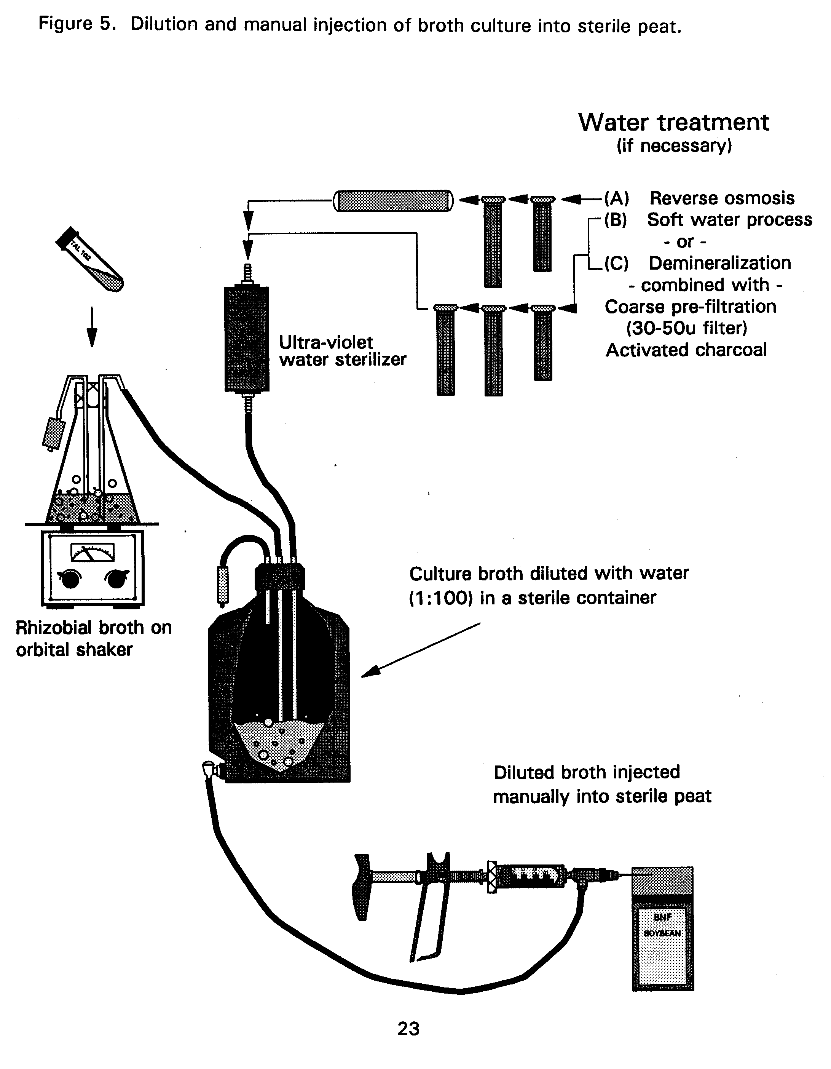
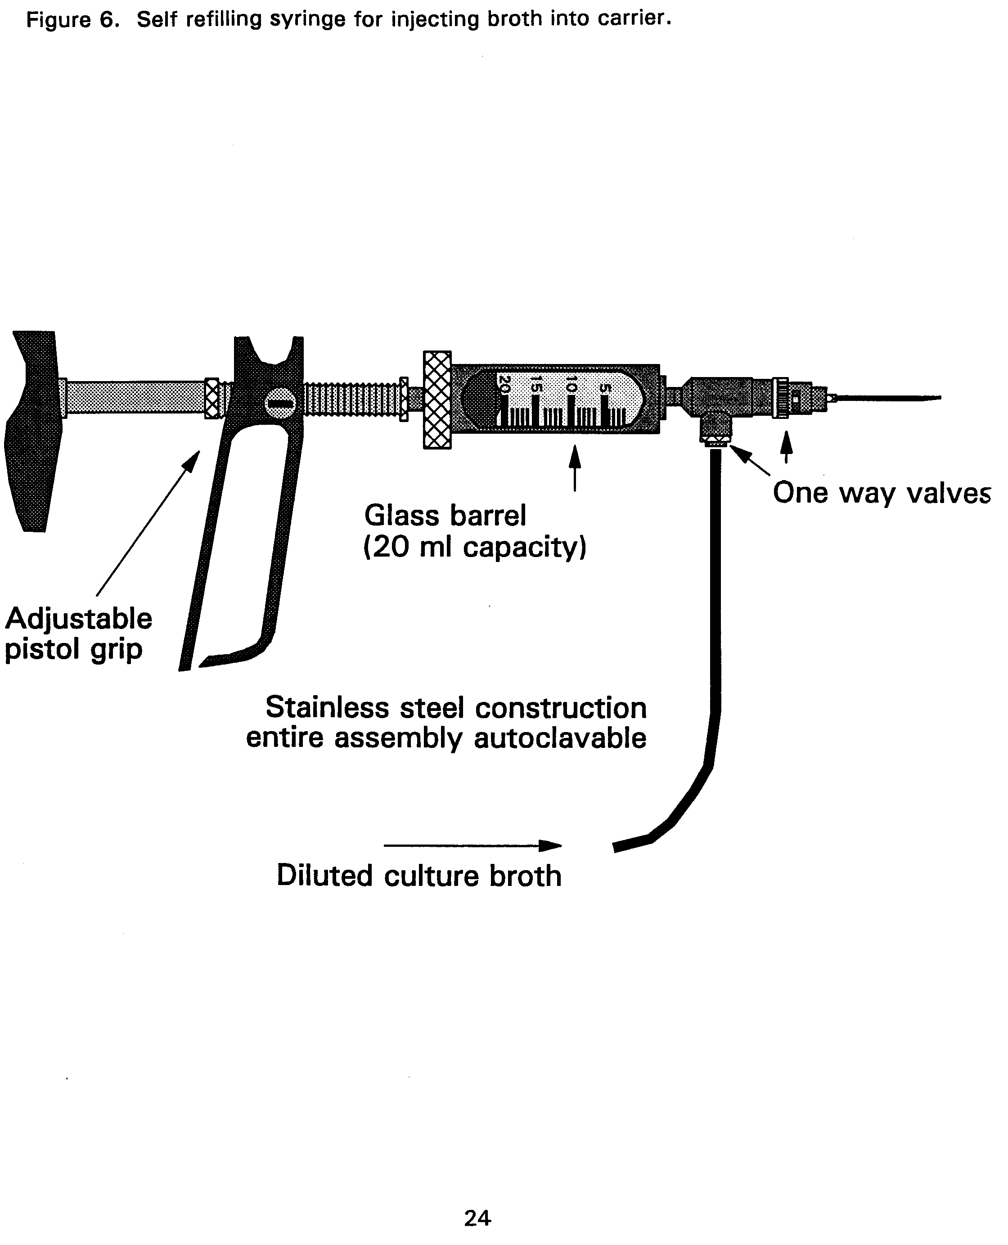
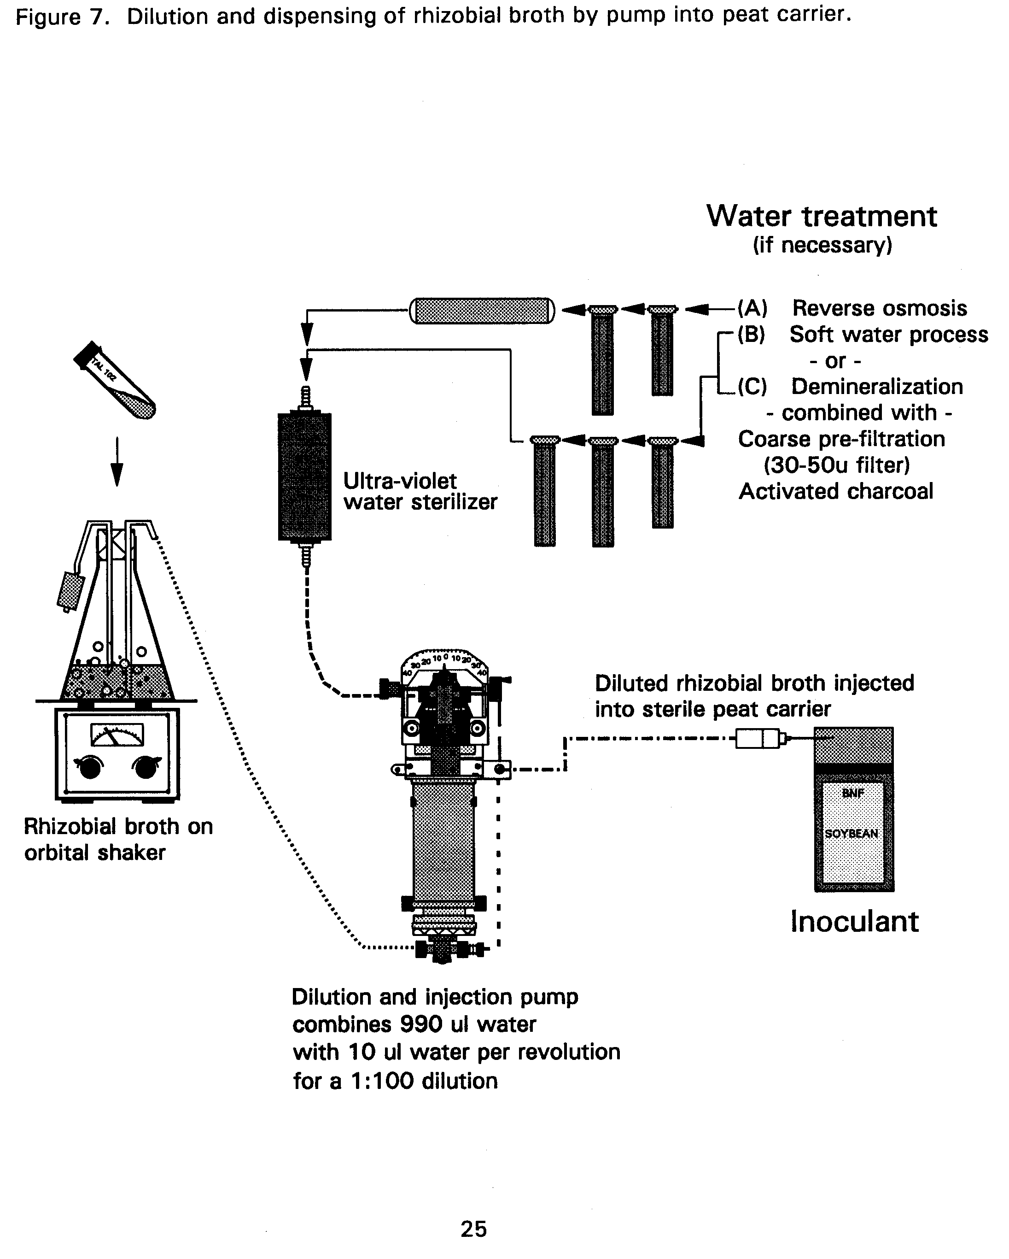
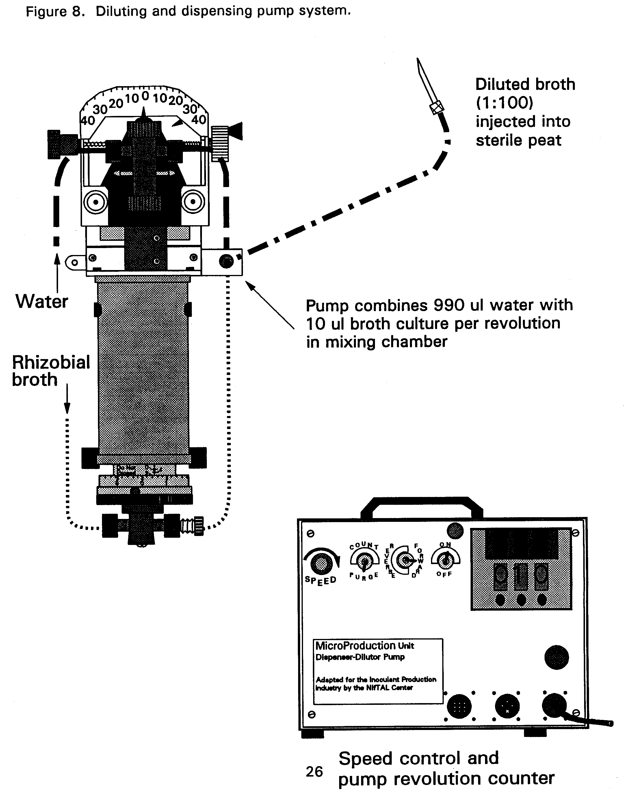
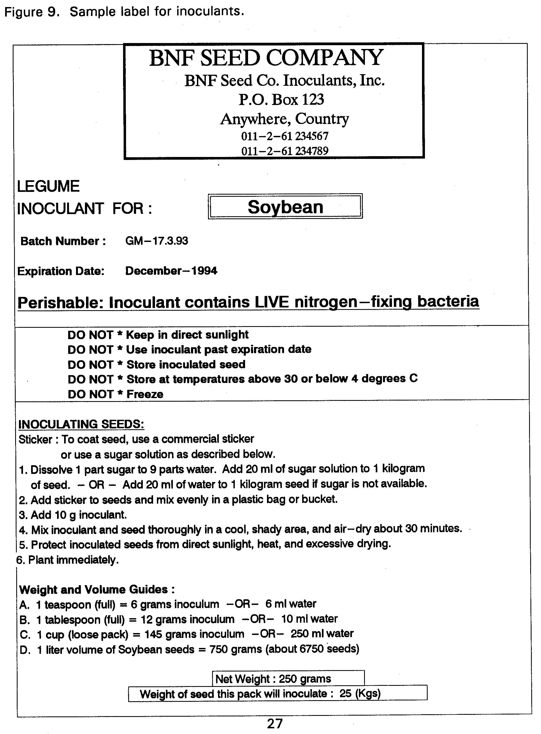
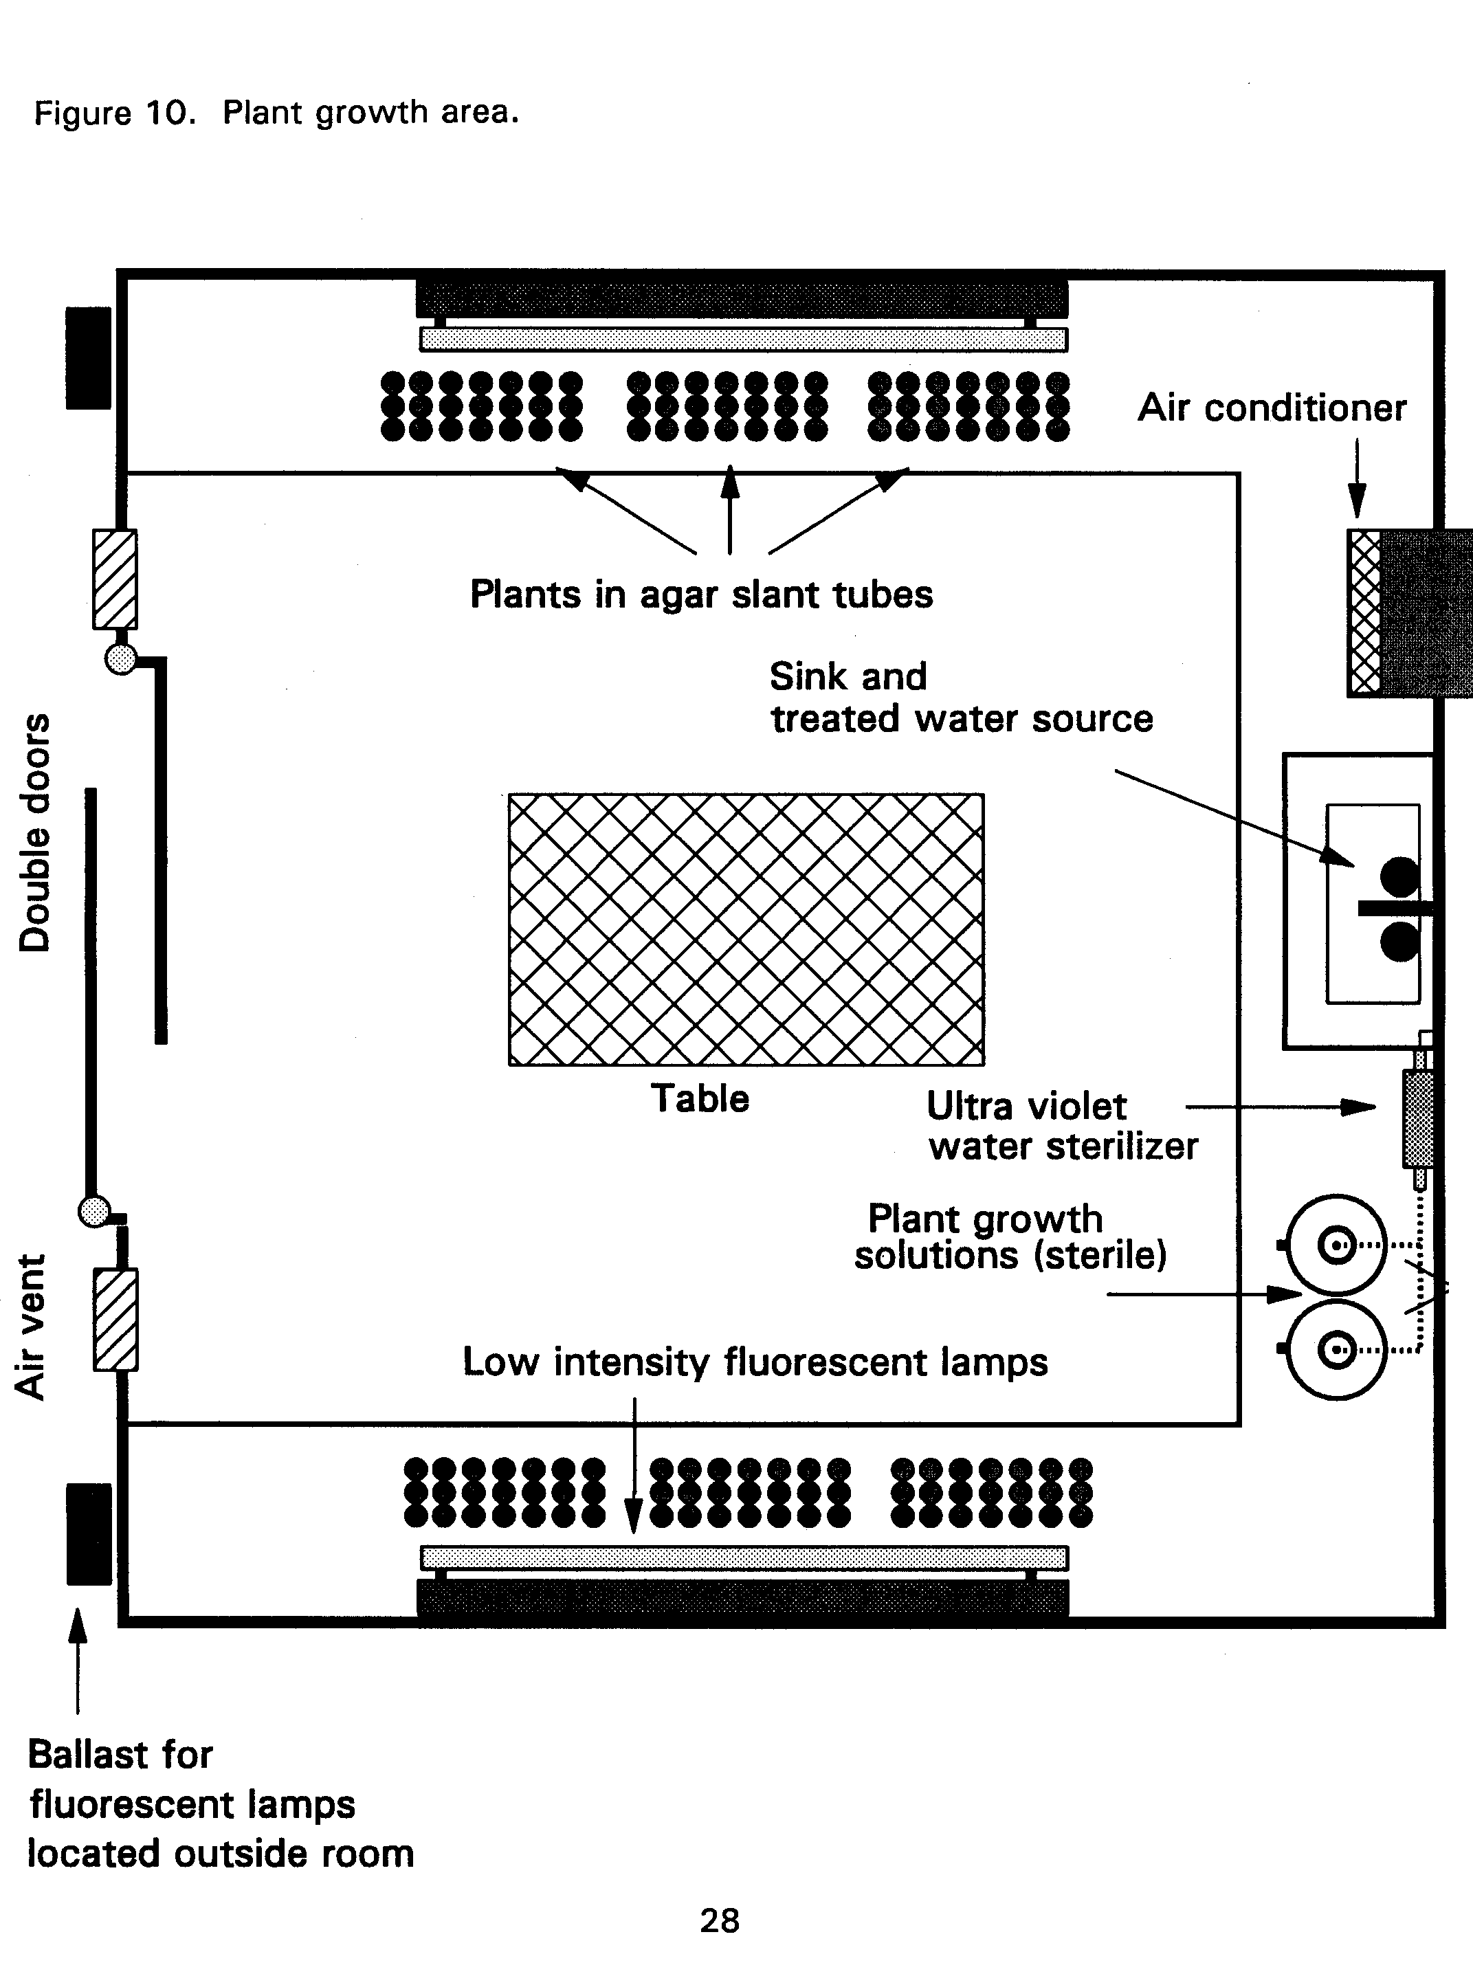
APPENDIX

NifTAL-Developed Computer Programs

Custom computer programs are available to support the financial and technical design of an MPU facility.

FAIME (Financial Analysis for Inoculant Manufacturing Enterprises)

FAIME analyzes strategies for allocating resources for start-up and operations based on expected production requirements. Key indicators of financial success are compiled and presented for review. The user may adjust figures and observe the effects of these changes on the indicators of financial success.

CAPACITY - (UNITS, TIME, COST)

UNITS, TIME, and COST are inter-active modules in single program entitled CAPACITY. Starting with UNITS, each module builds on the previous one to explore production capacities, fermentor units requirements, production times, and fermentor costs for expected production demands.

UNITS defines the number and volume of fermentors needed for specific inoculant requirements. Production time is also computed.

TIME defines personnel requirements to inject a known volume of broth into the carrier material. A number of variables allows modeling of production mode and scale.

COST compares the costs of the number of fermentors required to satisfy expected production demands in two production modes--sterile and non-sterile.

OUTPUT compares the two.

MPNES - Most Probable Enumeration System

MPNES provides rhizobial population estimates based on the results of MPN plant infection tests.

ACCLAIM - ACCounting for Laboratories by Automation and Information Management

ACCLAIM has three sections:

32

A) Database of NifTAL's Microbial Resource Center (MIRCEN) collection of rhizobia.

B) Recommended rhizobial strains for grain, tree, and pasture legumes.

C) Seed weights and inoculant application rates for selected legumes.

HEAT UP

HEAT UP allows the user to calculate kilowatt requirements for raising water temperature over a specified range.

Hardware Requirements

All programs can be installed on your computer providing you have the following hardware requirements.

1. DOS system, version 2.0 or higher
2. 512K RAM
3. 3.5" floppy drive
4. Recommended: Hard disk installation with 1 Mb free

33
The Use of Sterile or Non-Sterile Inoculant Carriers:
Which System is Best for You?

Inoculant Carriers : Inoculant carriers are a critical factor in the inoculant production system. After growing the rhizobial broth in fermentors, the rhizobia are mixed with an inoculant carrier material. The quality of the carrier depends on the number of rhizobia it can support. Good carriers can support one billion (109) cells per gram when the inoculant is fresh, and maintain 100 million (108) six months after production.

Carriers are most often finely ground peat, which has been proven as an industry standard. Other substances such as lignite, filter mud, charcoal, soil, and other locally available materials have also been used. The materials are processed so that they can support rhizobial growth and survival. They must also be fine enough to stick to the seed. For example, indigenous peat must be mined, dried, ground, and sieved. The resultant material is then limed before it is a can be used as a carrier to support rhizobia.

Inoculant production systems use either sterile or non-sterile carriers. Each mode of production has its own capital, material, and processing requirements. The advantages and disadvantages are presented below.

Production with Sterile Carriers : The use of sterile carriers means that the carrier material must be prepackaged and sterilized prior to incorporation of rhizobial broth. The inoculant producer must package and sterilize local materials on site, or purchase ready-to-use sterile (gamma-irradiated) peat packets from commercial suppliers. Small scale producers may be able to steam sterilize their own materials, but this heat sterilization may cause adverse changes to the carrier or packaging.

The primary advantage to using sterile carriers is that the Broth Dilution Technique can be used. With this dilution technique, full strength rhizobial broth from the fermentor is diluted with sterile water. This diluted culture is then injected into the individual bags of peat, and allowed to "cure" for 5 to 7 days at 24 - 28 °C. There, the rhizobia can use the nutrients in the carrier to regain its original "full-strength" population level. Inoculants produced with sterile carriers have a shelf life of four to six months if kept cool, and six to nine months under refrigeration.

Capital investments for fermentation systems are reduced when using the dilution technique. Dilution factors of 1:50 and 1:100 are often used in production. This dilution reduces the required fermentation capacity by the same factors. Quality control of the inoculants is also simplified. Because there are no other organisms in the carrier, the rhizobia can be counted directly using common microbiological techniques.

The major disadvantage to using sterile carriers is that sterilization facilities must be found, or pre-packaged, presterilized peat must be purchased from suppliers in the US or Australia. While this prepared material is convenient to use, transportation costs and foreign currency requirements for importing the peat packets may be obstacles.

Production with Non-Sterile Carriers : Introducing the rhizobial broth to non-sterile carriers can be as simple as pouring the broth into an open bin with a known quantity of carrier, and thoroughly mixing by hand or hoes. The mixture is then packaged. The curing requirements are the same as for sterile carriers. After curing, the inoculants must be kept under refrigeration to preserve the rhizobial population. Shelf life of non-sterile materials is much shorter than with sterile carriers because of the presence of other organisms in the inoculant. Without refrigeration, the quality of the product is questionable after a few weeks.

Advantages to using non-sterile production methods include the ease of physical processing of large amounts of material. Indigenous carriers can be used, and the dependence on imported, prepackaged carriers or sterilization facilities is eliminated. Requirements for stringent aseptic handling techniques are reduced, therefore the need for specially trained staff is also minimized.

The use of non-sterile carriers requires a larger fermentation capacity for producing the rhizobial broth culture because the dilution technique cannot be used. A comparatively larger inventory of supplies and chemicals is also needed. Because the product has a relatively short storage life, an stringent production schedule must be maintained to meet the demands of seasonal planters. In addition, quality control measures to enumerate the rhizobia in the peat will depend on plant infection tests, and the appropriate facilities to conduct the tests. Results may take up to four to six weeks.

34

